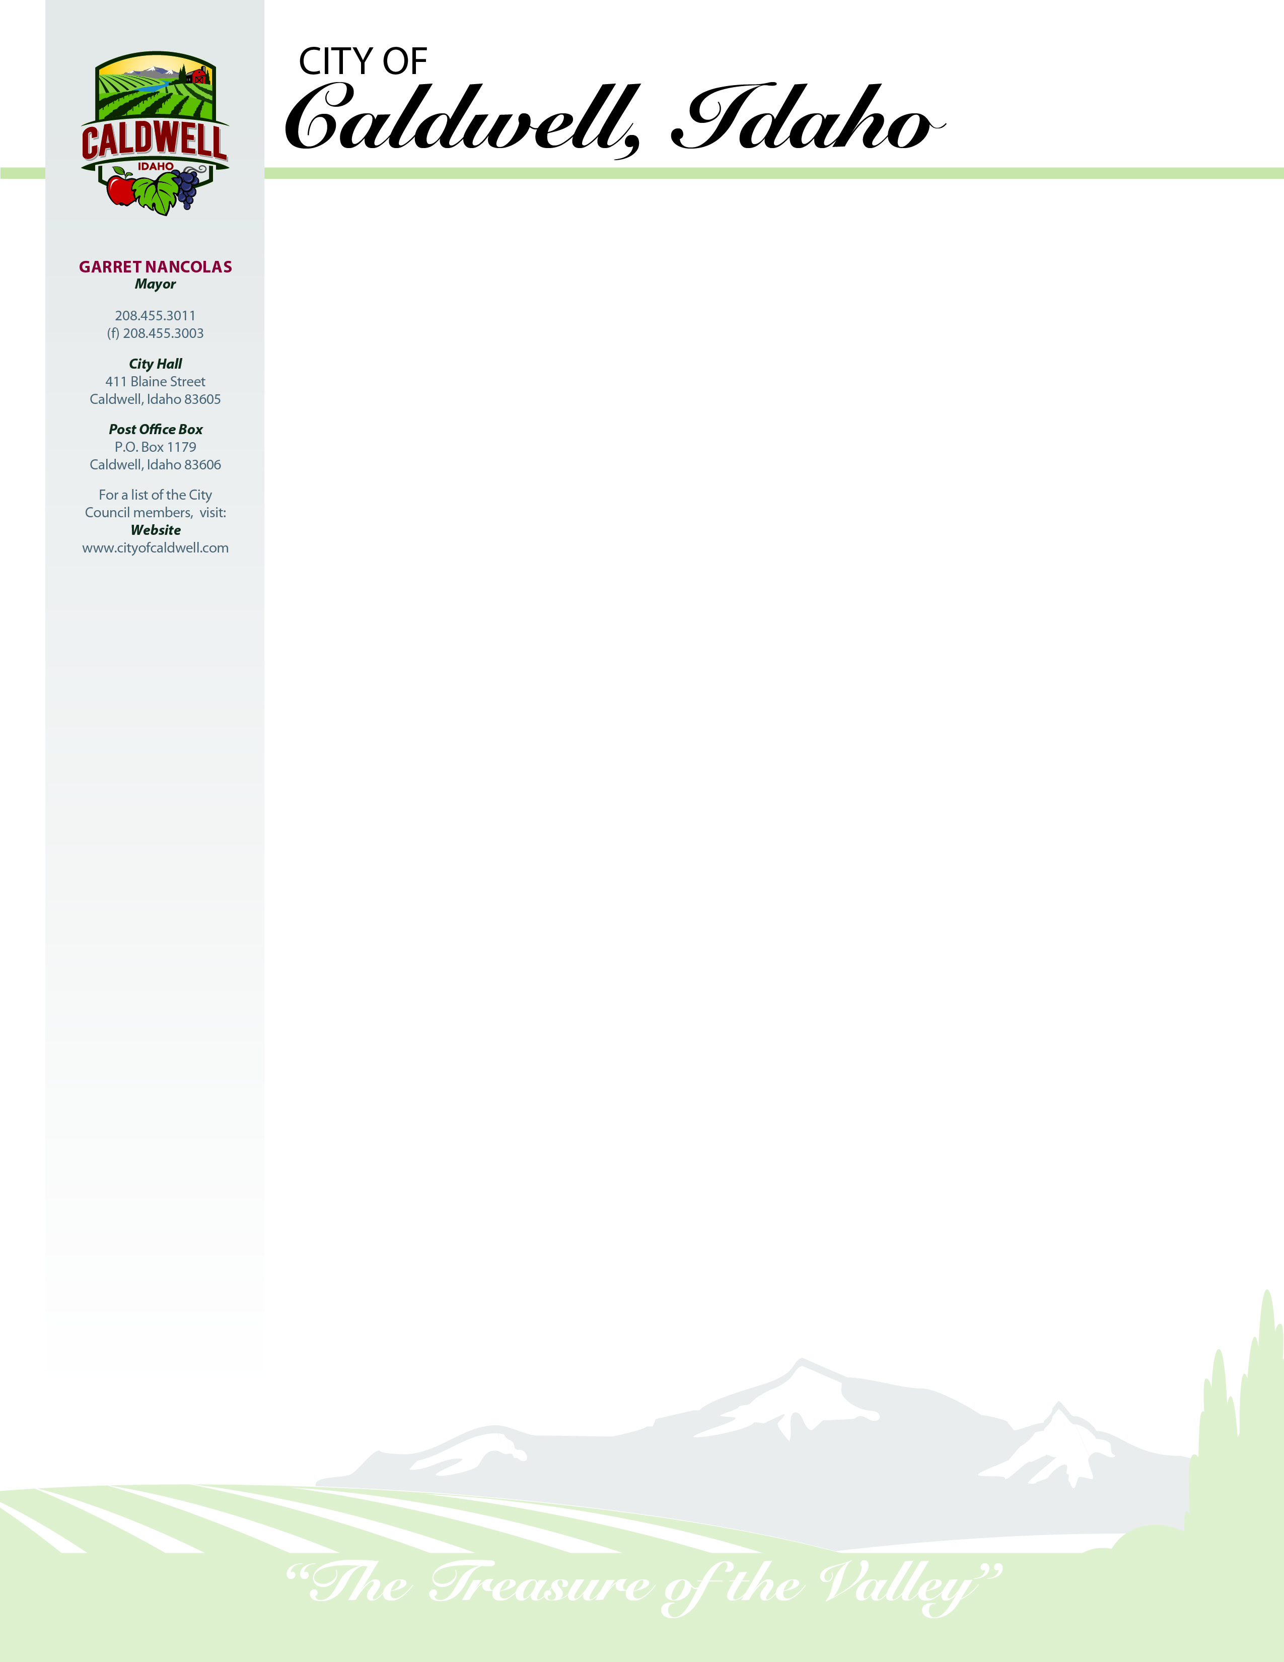

IPDES Municipal Permitting

DEQ State Office

Water Quality Division

1410 N. Hilton

Boise, ID 83706

July 22, 2019

**Laboratory Statement**

Caldwell, ID WWTP

EPA Lab Code: ID00949

NPDES Permit: ID0021504

I certify that this data complies with requirements under 40 CFR §136 and other analytical requirements specified in NPDES permit ID0021504.

Following an email conversation with Maria Lopez (EPA) December 20, 2016, we used the 1985 EPA *NPDES Self-Monitoring System User Guide* as a guide for performing our DMR calculations per her suggestion, with the exception of following the 22nd Edition *Standard Methods for the Examination of Water and Wastewater* rules for rounding and significant figures (SM 1050).

________________________________

Katy Keeton, Laboratory Technician

_______________________________

Kaitlin Chattin, Pretreatment Technician

**SALVADOR ARREOLA**

***Wastewater Superintendent***

208.455.3027

(f) 208.453.5032

***Treatment Plant***

208 Johnson Lane

Caldwell, Idaho 83605