**Avoid the FOG (fats oils & grease)**

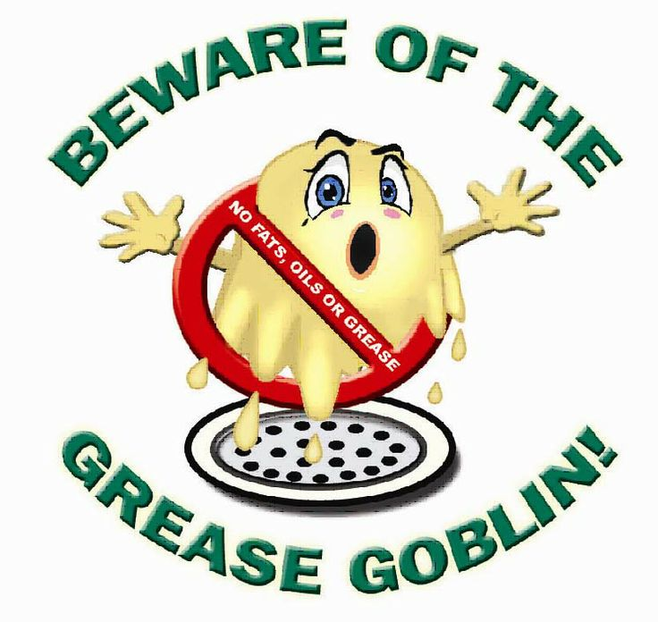

**Avoid backed up sewer pipes**

**Please don’t pour fats, oils or any kind of grease down the drain**

**Follow these rules:**

**Pour all greasy and oily waste from pots, pans, and fryers into grease waste container**

**Scrape all food wastes into the trash**

**Use drain screens to keep solid food and debris out of the plumbing and sewer system**

**Clean spills with towels absorbent materials such as kitty litter, and throw into trash**

**Empty containers before they are full to avoid spills**

**Get on a schedule for regular grease interceptor or trap cleaning**

**Provide employees with proper training for grease disposal and clean-up**

**Follow these rules and help prevent increased sewer cost, bad smells, and negative environmental impacts**

 