**FOG Program for Food Establishments**

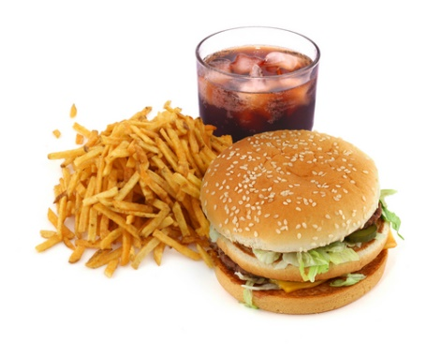

**What is FOG?**

FOG is any fats, oils and grease associated with food preparation, food service, and kitchen clean-up.

It becomes a problem for the community when it is poured down the drain and builds up in sewer pipes, pumps and equipment causing back-ups and overflows that are hazardous to health, homes, businesses, and the environment.

It can become a problem for your establishment if you are found to be the cause of a sanitary sewer overflow because of FOG or improper maintenance of a grease trap or grease interceptor located in your establishment.

You may be responsible for cleanup costs and property damage.

But there are ways to decrease the amount of FOG going down the drain and help to keep our community clean.

**What can you do to help control the FOG Program?**

* Have interceptors and traps designed and installed by a licensed plumber to handle the amount of grease expected from your facility.
* Clean and service the interceptors and traps on a regular basis.
* Do not add chemicals and additives that claim to dissolve grease.
* Follow the “Best Management Practices” (BMPs) provided to you by Pretreatment staff at the Caldwell Wastewater Treatment Plant.
* Keep good up-to-date records of all cleanings, maintenance, and service and have it available during inspections.
* Contact the Caldwell Wastewater Treatment Plant Pretreatment Department with any further questions 208-477-7953 or [dgarcia@cityofcaldwell.org](mailto:dgarcia@cityofcaldwell.org).

**Grease Handling, Storage, and Disposal**

* Do not pour cooking oil or grease into sinks, garbage disposals, toilets, floor drains, parking lots, storm drains, or the street.
* Install an oil and grease trap and/or interceptor to help reduce the amount of grease entering the city sewer system.
* Service oil and grease separators frequently based on the manufacturer’s recommendations and use.
* Check dumpsters and compactors regularly for leaking to prevent discharge to storm drains, or attraction of rodents and pests.
* Practice dry cleanup using a scraper to remove food waste from dishes and cooking surfaces before cleaning them with water. Dispose of this waste in the trash.
* Dispose or recycle cooking oil and grease through a licensed waste grease hauler or recycler.