**Homeowners Guide   
Reducing Fats, Oils and Grease in our sewers**

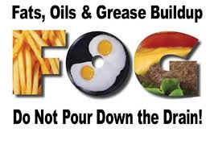

**What is FOG?**

Fats, oils and grease (FOG) are found in food scraps, meat fats, lard, oil, margarine, butter, sauces and dairy products. FOG is commonly associated with fried goods and baked goods prepared at home or in a good establishment. When FOG is not disposed of properly, it can clog your homes plumbing as well as city sewers.

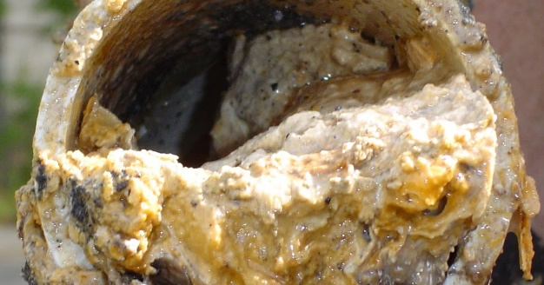

**Why should FOG matter to you?**

When washed down a sink or drain, FOG builds up over time and can cause a blockage in your drains, pipes and in sanitary sewers. Also, “flushable” wipes contribute to the blockage in sewers. Blockages lead to increased costs to maintain private plumbing, our sewers, the wastewater treatment plants, and public & private property.

* **Neighborhood:** Plumbing and sewer backups can result in property damage and various code violations. These backups can also create hazardous and unhealthy conditions.
* **Environment:** Clogged sewers can cause raw sewage overflows, which release untreated sewage into our rivers and streams. Sewer overflows make waterways unsafe for recreation, and they threaten the fish and other aquatic life that live in our rivers and streams.
* **Quality of Life:** Sewer backups and clogs attract insects and vermin, resulting in undesirable and unhealthy living conditions.

**How can you reduce FOG in our sewers?**

Pour cooking fat or grease into a small container. Once it cools or solidifies, place it in the garbage.

Don't dispose of FOG into food waste disposers, sinks, toilets, or floor drains.

Dispose of greasy solid waste in the trash.

"Dry wipe" pots, pans and other dishes before washing to minimize the amount of FOG and solids washed down the drain.

Do not put used cooking oil, oil-based paints, motor oil, solvents or other chemicals down sewer lines or storm drains. Large quantities of home cooking oil from fryers should be poured back into the original oil containers. For more information or questions visit: [www.cityofcaldwell.org](http://www.cityofcaldwell.org) or call 208-477-7953.

Educate others on the damage that FOG can cause.