**Industrial Pretreatment Program**

Food Service Establishment

Best Management Practices (BMP’s)



**The City of Caldwell**

**Public Works Department**

Table of Contents

**Introduction**

Purpose Page 3

Why grease is a problem? Page 3

**Standards**

City Ordinance Page 3

Discharge Prohibitions Page 3

Best Management Practices Page 4

Maintenance Page 4

Kitchen Operations Page 4

Measurement Criteria Page 5

**Technical Information**  Page 5

How grease interceptors work Page 5

Standard drawing of a Grease Interceptor Page 6

**New Construction**

Building Standards Page 6

**Service Providers**

List of Providers Page 7

FSE Process Flowchart Page 8

The City of Caldwell owns, operates, and maintains miles of wastewater collection pipes that everyday deliver approximately 7-8 million gallons of raw sewage to its treatment facility located alongside the Boise River. The facility processes that wastewater and discharges clean water called effluent into the Boise River under strict regulation and requirements imposed by a federal permit issued to the City of Caldwell by the Environmental Protection Agency (EPA). In order to protect the treatment facilities and the waterway from toxic, hazardous and untreatable pollutants, the City’s Industrial Pretreatment Program conducts facility inspections, sample monitoring, and educational outreach activities throughout the City to ensure compliance with Industrial Users (IU’s) sewer discharge regulations.

Fats, oils, and grease, FOG for short, have negative impacts on our wastewater collection and treatment process systems. Blockage of the sanitary sewer system; the EPA has determined most sanitary sewer system blockages are caused from buildup of FOG in the collection system pipes, causing sewer manholes to overflow raw sewage into public streets, homes and businesses causing serious public health safety conditions. High concentration levels of FOG in wastewater damages mechanical lift station pumping equipment and complicates treatment processes located at the Wastewater Treatment Plant.

**Purpose**

The development and implementation of Best Management Practices (BMP’s) for Food Service Establishments is recognized by the EPA as an effective and flexible tool to limit the discharge of undesirable pollutants such as grease to the sanitary sewer collection system and Wastewater Treatment Plant.

Ensuring that your grease abatement equipment is installed, properly maintained and most importantly cleaned on schedule is fundamental to avoiding blockages, backups, spills, and enforcement action by federal, state or city against your business. The discharge of grease to the sewer system is an illegal action set forth by Caldwell City Code.

**Standards**

Chapter 4 Public Works and Property, Article 7 Sewer Use and Management from the Caldwell Code of Ordinances sets forth uniform requirements for users of the Wastewater Treatment Plant for the City of Caldwell and enables the city to comply with all applicable state and federal laws, including the Clean Water Act and the general pretreatment regulations (40 CFR, Part 403).

*Prohibited Discharge:*

* Fats, oil, and grease in amounts that can or may cause an obstruction to the flow n a sewer.
* Direct introduction of enzymes, bio-additives, emulsifying agents or other similar chemicals into an interceptor to eliminate or reduce frequency of cleaning.

**Best Management Practices**

Maintenance

*Standard Interceptor Vault:* Clean the interceptor routinely; 45-90 day cleaning schedules are typical unless a facility can demonstrate a less frequent schedule is adequate. You must secure a cleaning service contract with a qualified pumping contractor, to conduct routine inspections and clean the interceptor (remove the FOG and transport to a disposal facility). You are legally responsible (liable) to ensure the proper disposal of FOG removed from your interceptor by your service provider. Interceptors must be cleaned routinely to ensure that FOG accumulation does not limit retention time and separation efficiency resulting in pass through of FOG to the sanitary sewer system.

**Note:** The cleaning frequency is a function of the type of food service establishment, size of the interceptor, and the volume of kitchen clean up wastewater flow discharged by the establishment.

*Electro-mechanical automatic trap:* Removes FOG collected inside the unit into a separate container; empty FOG collection container daily. Clean the solids strainer basket daily. Clean wiper blades weekly. Never remove flow restrictor from unit. Keep a cleaning log for future inspections. Grease abatement equipment cleaning records are required to ensure that the proper maintenance is performed on a regular basis. Keep cleaning log sheets on site available for review by the city inspectors.

**Note:** Adequate maintenance ensures maximum efficiency of the grease abatement unit.

*Passive type grease trap* is NOT ALLOWED *in new building construction.* A facility with an existing passive type grease traps is required to clean weekly unless the facility can demonstrate a less frequent schedule is adequate. Keep a cleaning log. Grease abatement equipment cleaning records are required to ensure that the proper maintenance is performed on a regular basis. Keep cleaning log sheets on site available for review by city inspectors.

**Note:** If the grease trap is not providing adequate protection, the City can require installation of additional grease abatement equipment.

**Kitchen Operation**

* Witness all grease trap or interceptor cleaning to ensure proper cleaning.
* DO NOT put enzymes or additives directly into interceptors or traps in order to reduce your cleaning schedule.
* Train kitchen staff to scrape excess food particles and liquid grease into dry trash or a separate container. Use paper towels to wipe excess grease from utensils and work areas.
* Post FOG poster above sinks and dishwasher.
* If clean-up sink drains to an under sink trap, lower final discharge temperature as not to melt grease and pass through trap.
* Clean up grease spills with absorbent materials.
* Clean hood filters and kitchen floor mats, discharge wastewater to your interceptor.
* Collect used grease and oil in a proper container. Check for possible leaks, avoid overfilling the grease drums. Ensure drum lids are tight.

**Measurement Criteria**

All food service establishments are inspected for compliance with BMP’s on a routine basis. The observation measurement criteria to determine the amount of grease contained in a grease interceptor is provided in Table 1. All grease interceptors are measured by city pretreatment inspectors trained in the proper use of tools and techniques required to determine the volume of grease. Both chambers are measured; the largest measurement dictates the maintenance. Judgement of the on-site inspector during facility compliance inspection is final. Failure to respond as directed may result in Administrative Enforcement Remedies by the city Chapter 4, Article 7 Sewer Use and Management from the Caldwell Code of Ordinances.

**Technical Information**

A grease interceptor is a large capacity underground double chamber vault connected to the discharge of wastewater generated only from kitchen operations. The large capacity of the vault slows down the flow rate of wastewater, allowing oil and grease to separate. Grease will float to the surface and solid material to settle to the bottom of the chamber. These vaults are required to be installed outside the building as near as possible to the source of oil/grease. Oil and grease floats on the water surface and accumulates in each chamber behind the grease retaining fittings (inlet tee and outlet tee connections, figure 1) and the wall separating the compartments. The oil and grease will be removed during routine interceptor cleanings. Solids material in the wastewater that does not float will be deposited on the bottom of the grease interceptor and will need to be removed during routine grease interceptor cleaning. The inlet tee and outlet tee pipes extend down into the water to within 12-14 inches of the bottom of the interceptor. Because grease floats, it generally does not enter the tee pipe and is not carried into the next compartment. The tee pipes exte4nd above the water surface to provide air relief. Flow exits the interceptor through the outlet pipe and continues on to the sanitary sewer system.

Standard Drawing of a Grease Interceptor

Figure 1: Grease interceptor detail

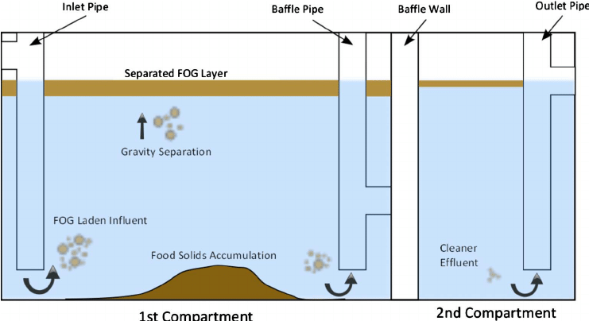

**New Construction**

*Building Standards*

All new construction commercial building and tenant improvement architectural design plans submitted to the city are reviewed and approved by city engineering staff. Grease abatement equipment will be required if determined necessary at that time. The City’s approved standard for FSE grease interceptor is 1500 gallon capacity (minimum), double chamber in-ground vault. Interceptors are required for high volume fast food or full menu establishments such as hotels, hospitals, factories, or school kitchens.

**Service Providers**

The following independent vendors provide cleaning services for FSE in the local area.

NOTE: Service Providers are **NOT** endorsed by the City of Caldwell.

ABC Septic Plumbing 208-888-2474

Express Plumbing 208-402-8718

Master Rooter 208-922-6686

Roto Rooter 208-562-8040

United Site Services 1-800-864-5387

File in Facility File, Record in Data Base

Inspection Report

Site Inspection

Cleaning record at facility

Yes

Cleaning record or verification

External Data Record from Service Provider

No

Yes

Contact Service Provider

Legal action by City

Yes

No

NOV Letter

No

Notice to Clean Letter 5 days by date received

No

Yes

**Food Service Establishment**