**CORRECTIVE ACTION AND AIM DOCUMENTATION**

**Description of Condition:** During a Routine Facility Inspection, the stormwater inspector found exposed earth and rill erosion at stormwater swales upstream of the following outfalls: AP-10, AP-09, AP-08, AP-04.

**For Spills and Leaks:** Not applicable.

Description of Incident:

Material:

Date/Time:

Amount:

Location:

Reason for Spill:

Discharge to Waters of U.S.:

**Date:** Date of Inspection was December 2, 2021. Grass seed was spread upstream of each of the outfalls on the exposed earth and observed erosion sites on December 23, 2021.

**Immediate Actions:** Read the Routine Facility Inspection report and determine the urgency. Each of these sites already received stabilizing measures following the City’s IPDES Compliance Audit and inspection in October 2019. Each of the swales are stabilized or partially stabilized upstream of the outfalls.

**Actions Taken within 14 Days:** Assign remedial tasks to staff following release of the Routine Facility Inspection on December 3, 2021.

**14 Day Infeasibility:** Stormwater inspector completed the Routine Facility Inspection on her last day of employment. Staffing shortage immediately followed, so it was difficult to execute her recommendations promptly.

**45 Day Extension (if applicable):**  A small portion of the 45-day extension was needed here. The seeding is best placed under cool moist conditions.

**Notes:** On December 23, 2021 I placed an approximate total of 16 lbs of crested wheatgrass seed on: (1) the borrow ditches and edges of the AP-10 swale, which has already been stabilized with cobble, (2) the tributary swale fingers and upstream bottom of AP-09 “fish shaped” swale, (3) the northwest slope of the AP-08 swale, where the upper half of the slope was still exposed earth in some locations, and (4) the northwest sideslope of the AP-04 swale. This work was performed to facilitate the growth of vegetation, stabilize the swale slopes, and minimize erosion of sediment toward stormwater outfalls.

s/s Ashley Newbry 3:54 PM 12/28/2021

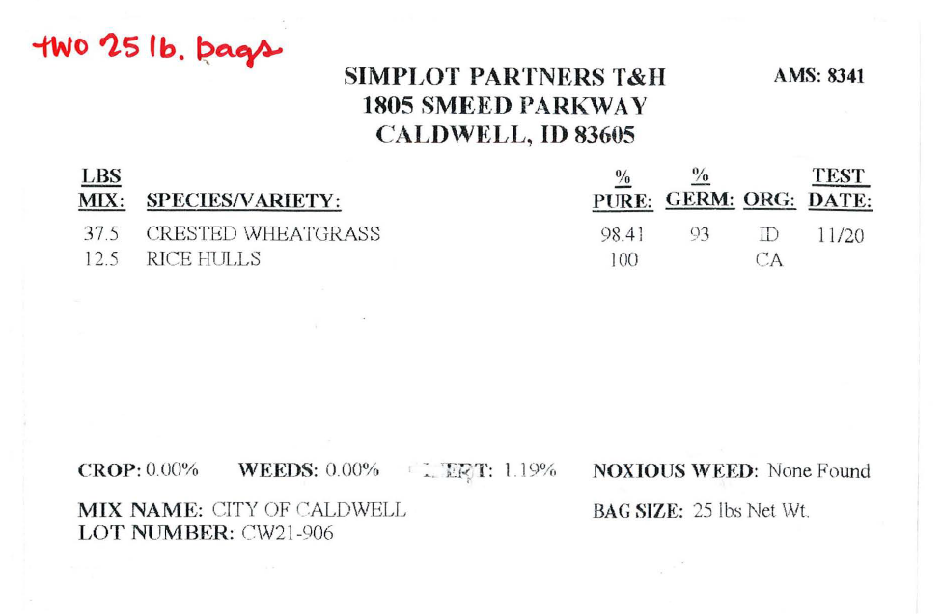

Also, on 12/28/2021, Paul Alsup, Assistant Superintendent of the Caldwell Street Department submitted the following:

Airport EPA/FAA repairs and cleanup

12/28/21

As prescribed, the following work was completed at the Airport:

* Trim, but don’t remove by the root, the willows at the inlet of AP-06. GPS Loc: (43.639456, -116.640522)

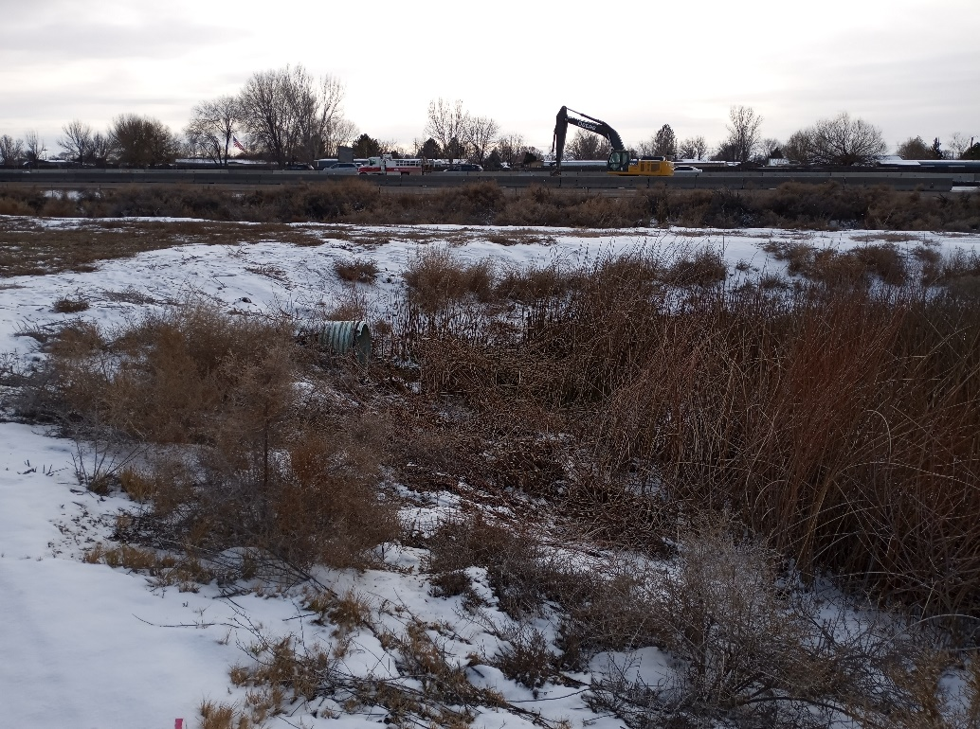

* Add cobbles (from WWTP) to the corner of AP-11 to stabilize the erosion that is occurring.  GPS Loc: (43.648093, -116.641810)

