CITY OF

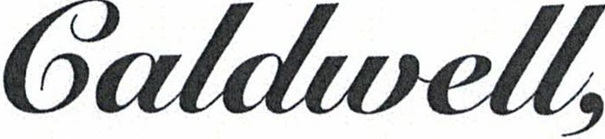 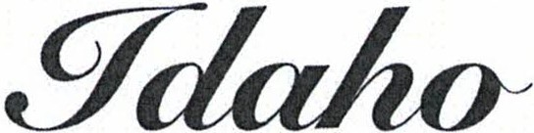

**GARRET NANCOLAS**

***Mayor***

208.455.3011

(f) 208.455.3003

***City Hall***

411 Blaine Street

Caldwell, Idaho 83605

***Post Office Box***

P.O. Box 1179 Caldwell, Idaho 83606 '

For a list of the City Council members, visit:

[www.cityofcaldwell.com](http://www.cityofcaldwell.com/)

James Craft Compliance Officer

Idaho Department of Environmental Quality Boise Regional Office

1445 North Orchard Street Boise, Idaho 83706

August 18th, 2022

Re: Sanitary Sewer Overflow

Dear M r. Craft,

This purpose of this letter is notify IDEQ of a of a sewer overflow that occurred at 520 Linden Rd. Caldwell Idaho. The On-Call operator was called at approximately 1550 pm Tuesday August 16th and notified by a plumber that there appeared to be a sewer backup at manhole #563 and causing sewer to enter the basement. Upon arrival to the site the City Collections team confirmed the mainline to be plugged with a large mass of wipes creating a surcharge in the 8” mainline. The collections team cleared the line as per procedure and normal flow was restored to the collection system at approximately 1630. It is an undetermined volume due to the collections team not entering the residence. No sewer reached the road deck or any receiving waters. The homeowner had a cleanup service coming.

Please feel free to contact us if you have any questions regarding this situation. Thank you for your time and attention to this matter.

Sincerely,

C:\Users\dharmon\AppData\Local\Microsoft\Windows\INetCache\Content.Word\Tony Harmon Signature0001.jpg

Wastewater Superintendent