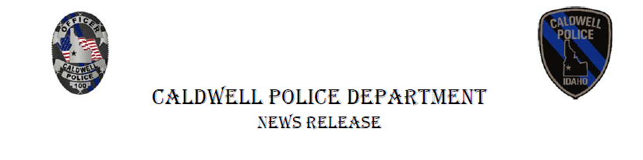

Contact:

Char Jackson

Public Information Officer

(208) 455-4524

cjackson@cityofcaldwell.org

October 18, 2022

The Caldwell Police Department is proud to announce the addition of Deputy Chief Shawn Sopoaga to the team. As part of the restructuring, by Caldwell Police Chief Rex Ingram, Deputy Chief Sopoaga will be sworn in at the regular City Council meeting on October 20 at 6 p.m. The meeting is held at the community room at the Caldwell Police Department, 110 S 5th Ave, Caldwell, ID 83605.

Deputy Chief Sopoaga comes to us from Boise Police Department, where he served as a recruiting coordinator, watch commander and lieutenant. His 16 years of police experience also includes serving as the Commander of the Humboldt County Regional Drug Task Force and SWAT Commander. Deputy Chief Sopoaga has earned a B.A. in Communications from the University of Northern Colorado, and a M.S. in Law Enforcement Public Safety Leadership from the University of San Diego. He has attended the Sherman Block P.O.S.T. Leadership Institute and holds multiple P.O.S.T certificates. He is a member of the Police Research Forum, The National Tactical Officers Association and the International Association of Chiefs of Police. DC Sopoaga played college football for both Idaho State and University of Northern Colorado.

We are proud to announce that three other officers will also be sworn in that evening.  Moises Montes was born in Caldwell and began his law enforcement career in 2009 as a Level I Reserve Officer for the Homedale Police Department and later transferred to the Owyhee County Sheriff’s Department in 2015. Officer Montes says he looks forward to being a part of a great team and the many opportunities CPD has to offer.

Nilton Melara, comes to CPD from IDOC where he was a correctional officer for two years. Officer Melara says he has dreamed of becoming a police officer since age nine and hopes to someday become a K9 officer. In his free time he enjoys spending time with family and friends, playing the piano, and being an artist. He is excited to begin his next adventure with the Department and looks forward to meeting amazing people.

Dwight Penkey began his law enforcement career in 2021. In his free time, he enjoys running, camping, hiking and spending time with his family. Penkey says he is very passionate about law enforcement and wants to use his skills to help make a difference in the community.

“The Caldwell Police Department continues to recruit and attract the very best human beings to serve this community. We are excited to watch our newest family members protect and serve our great city,” Caldwell Chief of Police Rex Ingram said.