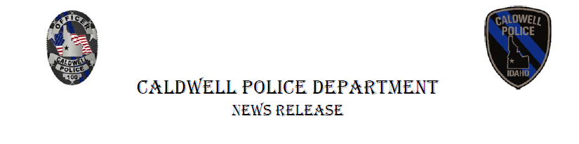

**October 20, 2022**

**Domestic Violence Awareness Car Joins CPD Fleet**

The Caldwell Police Department and Advocates Against Family Violence (AAFV) are proud to unveil the CPD Domestic Violence Awareness patrol car. The event will be held on October 24, at 11 a.m. at the AAFV campus at 1508 Hope Lane in Caldwell.

"Advocates Against Family Violence is so very honored to be working with the Caldwell Police Department in efforts to end domestic violence. October is Domestic Violence Awareness Month, and what a way to close out bringing more awareness to the community. However, it's not just about awareness. Domestic abuse is a social epidemic. All victims and survivors need to know they are not alone and at AAFV we have advocates and support systems to assist them on their journey to freedom," says Kim Deugan, Executive Dir., AAFFV.

“This purple ribbon car provides us the opportunity to raise awareness about domestic violence in our community and the harm it does to families. It reinforces to the community that individuals can get help from law enforcement and from organizations like Advocates Against Family Violence who provide critical services like counseling, housing and other resources to help victims and help break the cycle of violence,” said Rex Ingram, Caldwell Chief of Police.

TO REPORT DOMESTIC VIOLENCE: Caldwell area residents can call 911 or contact dispatch by calling 208-454-7531. If you or someone you know needs help, you can also call the AAFV 24-hour domestic violence hotline at (208) 459-4779.

We want to thank The Sign Shoppe of Caldwell who worked with Caldwell PD to design the Domestic Violence Awareness patrol car. This car joins two other specialty cars in the CPD fleet, a College of Idaho car and a Pink Ribbon Breast Cancer Awareness car.