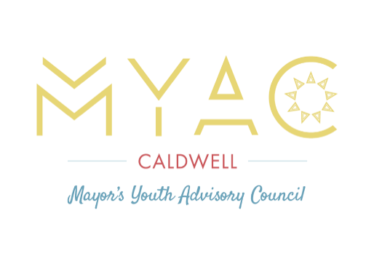

May 17th , 2023

5:30 PM

Caldwell Police Department

Caldwell, ID

Executive meeting, 5:00 pm / General meeting, 5:30 pm

|  |  |
| --- | --- |
| **Standing Committees:**  **Finance: Treasurer, Eva Wade - Ridgevue**  **Legislative: Vice Chair, Julissa Hernandez - CHS**  **Secretary: Courtney Case - ISVH**  **Activities: Historian, Gladys Rangel - CHS**  **Bylaws: Chair, Giselle Wade - Ridgevue**  **Recruitment Officer, Noelia Rodriguez - CHS** | **Agenda:**  **5:30 pm**-Welcome and Mixer game  **5:40 pm-** Speaker: Mayor Jarom Wagoner  **6:50 pm-** Elections for the 2023-24 MYAC year!  **6:30 pm-** Reminders and announcements |

**Reminders:**

* Thanks to everyone who came to Clean Up Caldwell!
* Senior send off
  + June 2nd
    - From 6 p.m. to 8 p.m.
  + At Mayor's house
* Keep in touch with us over the summer!
  + We will have opportunities to serve in different capacities over the summer
  + Also, even if you don’t land an Executive Committee position, but would like to be involved at a higher level, let us know!
  + All questions, interest, or anything else reach out to Bryan ([bkida@cityofcaldwell.org](mailto:bkida@cityofcaldwell.org) or through group me)
* Join A Sub-committee!
  + Sub-committees meetings are held the first Wednesday of the month.
    - Health and Wellness committee- overseen by Eva Wade and Giselle Wade.
    - Education committee- overseen by Gladys Rangle and Julissa Hernandez.
    - Fine Arts committee- overseen by Noliea Esquivel Rodrigez and Courtney Case.
  + Don’t forget you can apply to start your own Sub-committee!
* Don’t Forget to join the MYAC Group Me to stay updated!

*Mission Statement: To empower youth by engaging them in community service, the decision-making process, and leadership within their community.*

**Meeting:** April 19th , 2023

**Minutes:** 5:24 pm to 6:34 pm

In MYAC's last meeting on April 19th, we gave announcements for future events like:Silverwood, senior send off, and elections. Then the executive committee gave a basic summary and likes/dislikes about their positions. Finally we had MYAC’s vice chair, Julissa Hernandez, give a presentation about her inspirations and successes through her adversities!