**City of Caldwell**

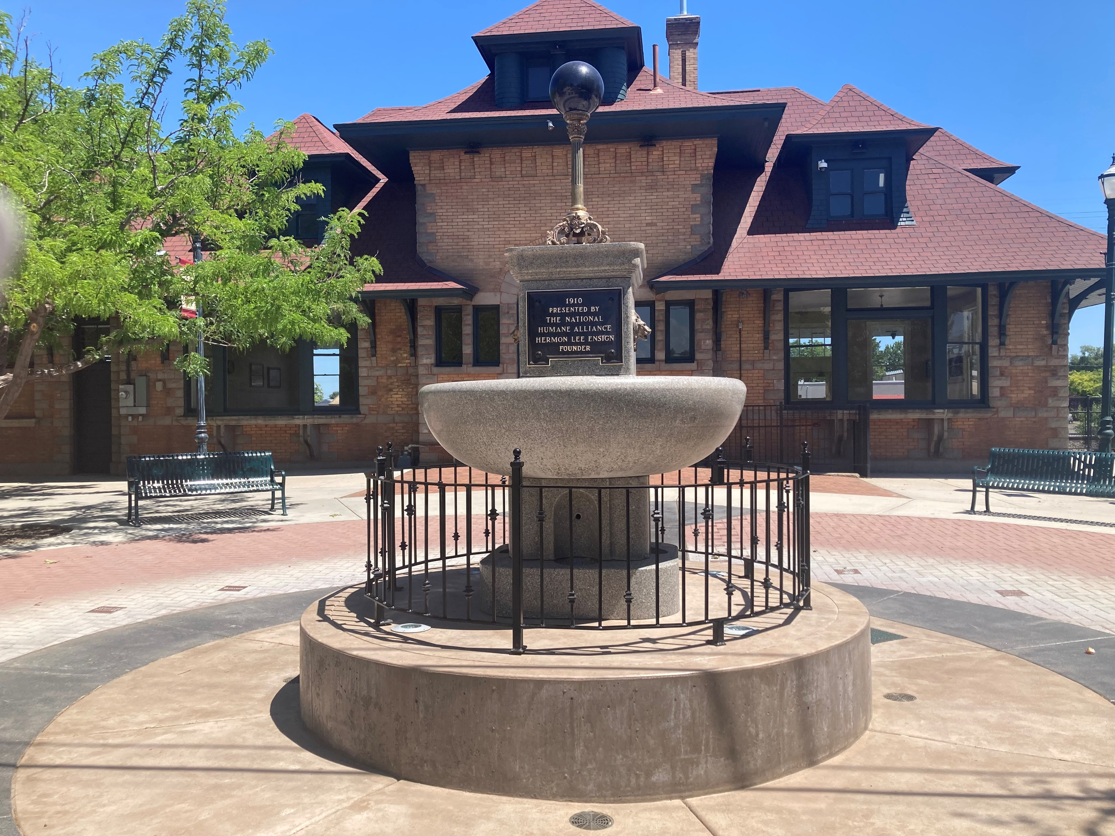

Train Depot/Plaza Event Center

701 Main Street – Caldwell

Contact the Caldwell City Clerk’s Office with

questions: 208-455-4770/208-455-4656

Website: <https://www.cityofcaldwell.org/live/historic-caldwell/caldwell-train-depot>

**Reservation Form**

Activity Date: Type of Activity: ____________________________________________

Time that set-up begins: Time of event: _______________ to ________________

Anticipated number of persons in the building ___________ (maximum capacity is 115)

Group Name: _________________________ Point of Contact _____________________________

Address: ________________________________________________________________________

E-Mail Address: ___________________________________________________________________

Phone: (days) ____________________________ (evening or cell) ________________________

I understand by renting the Caldwell Train Depot facility, I agree to the following conditions:  **(Please initial)**

_______ I understand that the ***refundable* deposit** in the amount of $200 must be *submitted with the application*. This holds your date on the Depot Event calendar

_______ I agree to pay the full amount of the rental fee no later than two weeks before the event.

RENTAL FEES: Please check the appropriate boxes below:

REFUNDABLE Key & Cleaning Deposit (check or cash please) $200 (kept on hold)

Depot only (includes only the use of the interior of the Depot) $450 + 6% tax ($477)

Plaza only (includes use of outside plaza area – no restrooms) $150 + 6% tax ($159)

Depot Building AND Depot Plaza $600 + 6%tax ($636)

Tables Rental Qty. _______ @ $7 each + 6% tax = $___________

Chair Rental Qty. _______ @ $1 each + 6% tax = $___________

**TOTAL _____________**

**For weekend events, the key may be picked up at the City Clerk’s Office at noon on the Friday prior to the event. For weekday events, the key is available the day of the event.**

**I understand that by acknowledging the following items that I will be accepting responsibility for the Caldwell Train Depot facility and its contents as addressed within this rental agreement (please initial next to each item):**

I agree that the key will be returned to City Hall on the next working day **before noon** following the event or a **$25 late fee** will be assessed.

_____ I agree to hold the Friends of the Depot and the City of Caldwell harmless from loss, damage, or liability caused by the tenant or the tenant’s agents, employees, or invitees.

Activities or events that are deemed at risk by the City Clerk may be required to furnish liability insurance coverage as outlined in City Code.

__ I agree that there will be **no alcoholic beverages served or consumed** on the premises (including the Depot Plaza) unless an alcohol beverage catering permit is obtained through the City Clerk’s Office in accordance with Caldwell City Code. I further understand that any violation to this standard will result in the loss of future use of the building by the applicant and a forfeit of the deposit, possible liability for the expenses associated with any damages to the building or premises, and any other penalties associated with the violation of City Code or Idaho Code.

__ I understand and agree that all noises, including music, originating and emanating from the depot facility or its vicinity during the event, must be kept below a level that would cause disturbance to the neighboring properties and to the downtown area, generally. I recognize that there are both private and public areas within close range of the depot facility, the occupants of which have a right to quiet enjoyment and use of said areas. Accordingly, I acknowledge that ***I am personally responsible*** to ensure that my and my group’s use of the depot facility and its vicinity will comply with the limitations and regulations set forth in the Caldwell City Code at Chapter 7, Article 13 (“Public Noise Disturbance”), and that my use of the depot facility and its vicinity, even if in technical compliance with the City’s Public Noise Disturbance ordinance, will not disturb those persons and/or businesses in the downtown area. I further will ensure that no music audible from the exterior of the depot facility during the event will contain lyrics that are vulgar or obscene or which contain profanity.

__ I agree that there will be no smoking within the depot facility. I further agree that there will be no open flame devices or dangerous flammable products brought into the building or onto the premises at any time during the event. All combustible waste will be removed from the premises at the end of the event.

_ I agree that there will be no adherence of any objects to the walls, ceilings, window frames or windows. If items are placed on windowsills without protection and windowsills are scratched or damaged, I will be responsible for damages and understand that **a portion or all** of the cleaning deposit will be forfeited and additional charges for repairs could be assessed.

_ I agree that the event is not a politically affiliated function such as a political campaign, demonstration, meeting of any political party, or church services.

I agree that I am responsible for the action of my guests and, therefore, am liable for any damages done to the facility. I agree to repair or replace any property which is damaged during the period of this rental agreement.

_ I agree that the premises must be vacated no later than 11:00 p.m.

_ I agree that the building will be returned in a **clean and orderly condition** including all garbage removed from the building and placed in the large gray trash receptacle on the west side of the building, trash can liners replaced in the interior receptacles, litter removed from the floors, no personal items left in the building or plaza area, and all lights are turned off. I understand that if these conditions are not met, the cleaning deposit will be forfeited and that an additional cleaning charge may be assessed.

_ I agree that the oak bench located in the west side waiting area **will NOT** be moved from its present location without written permission from the appropriate city staff.

_ I understand that if the **floor, walls, windowsills or baseboards** are scratched or marred, I will be responsible for damages and understand that **a portion or all** of the cleaning deposit will be forfeited and additional charges for repairs could be assessed.

_ I agree that the racks from the Depot storage unit that hold the tables and chairs will not be taken inside the building, since they could damage the floor. I will be responsible for damages and understand that **a portion or all** of the cleaning deposit will be forfeited and additional charges for repairs could be assessed.

_ I agree that no vehicles will be driven or parked in front of the train depot for loading/unloading purposes.

_ I agree that the rental agreement will not be assigned to any other party.

I have read, understand and agree to this Agreement and hereby acknowledge receipt of a copy of this Agreement.

This rental agreement must be signed by the *responsible party* who will be *present during the function.*

**Signature: Date:**

***Submit Application to:***

***City of Caldwell, ATTENTION: City Clerk***

***205 South 6th Avenue***

***Caldwell, ID  83605***

***Phone: (208) 455-4656 or (208)455-4770***

***Cancellation/Refund Policy:***  *A refund of the Rental Fee and Deposit (minus a $15 processing fee) will be issued if the event is cancelled prior to seven (7) days of the reservation.*

*The entire deposit will be forfeited if cancelled within 6 days or less of the reservation.*

*NOTE: A refund of the damages/key deposit will not be made until the key has been returned prior to noon the next working day following the event AND the building has been inspected for any violation to the conditions within the rental agreement.*

***City Staff Only***

|  |  |  |  |  |  |
| --- | --- | --- | --- | --- | --- |
| Date received |  | Alcohol Catering Permit  On file with City Clerk? | | **YES** | **NO** |
| $200 Deposit Paid  (Date & Amount) |  | Rental Amount Paid  (Date & Amount) | |  | |
| Table Rental and Chair Rental | Tables (number and fees due) | | Chairs (number and fees due) | | |
| Signature of City of Caldwell staff member receiving application & rental fees. | |  | | | |

Updated 9/30/2024 (em)